How to Download

Library ebooks

KINDLE FIRE

**Before you can check out ebooks from SMPL, here’s what you need:**

* A Kindle Fire device with Internet
* An ***active*** **St. Marys Library** library card
* Your Kindle / Amazon ID and password

1. Download **OverDrive** from the App Store (it’s free).

2. Once your download is complete, open the

OverDrive App.

The first time you open the app, you’ll be prompted to enter your OverDrive account information (email address & password).

If you don’t already have one, you can set one up by selecting “Sign Up.” [*If you do have an OverDrive account, enter your info and proceed to step 5.*]

3. Create an OverDrive account by entering

your name, email address, and a password in

the appropriate boxes.

Write down your account information and keep it in a safe place. (You can complete this step at a computer through overdrive.com, if you prefer.)

4. Check your email account for a verification message from OverDrive; click the link

in this email to finish creating your account.

5. Now return to the Overdrive App on your

Android device. Tap the Home menu icon:

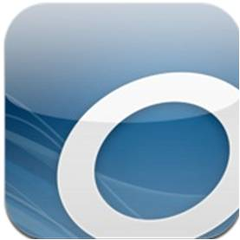

6. Tap “Add a Library.” Browse or Search

until you find “**St. Marys Public Library**.”

[*It is easiest to search with the zipcode. There are a lot of St. Marys libraries!]*

7. After selecting “**St. Marys Public Library**” from the list of PA libraries, select “**Warren Library Association**” to be brought to our ebook catalog.

How to Download

Library ebooks

KINDLE FIRE

**Before you can check out ebooks from SMPL, here’s what you need:**

* A Kindle Fire device with Internet
* An ***active*** **St. Marys Library** library card
* Your Kindle / Amazon ID and password

1. Download **OverDrive** from the App Store (it’s free).

2. Once your download is complete, open the

OverDrive App.

The first time you open the app, you’ll be prompted to enter your OverDrive account information (email address & password).

If you don’t already have one, you can set one up by selecting “Sign Up.” [*If you do have an OverDrive account, enter your info and proceed to step 5.*]

3. Create an OverDrive account by entering

your name, email address, and a password in

the appropriate boxes.

Write down your account information and keep it in a safe place. (You can complete this step at a computer through overdrive.com, if you prefer.)

4. Check your email account for a verification message from OverDrive; click the link

in this email to finish creating your account.

5. Now return to the Overdrive App on your

Android device. Tap the Home menu icon:



6. Tap “Add a Library.” Browse or Search

until you find “**St. Marys Public Library**.”

[*It is easiest to search with the zipcode. There are a lot of St. Marys libraries!]*

7. After selecting “**St. Marys Public Library**” from the list of PA libraries, select “**Warren Library Association**” to be brought to our ebook catalog.

8. Either search or browse to find an available ebook to download.

Ebook titles feature a book icon on the cover (while audiobooks are indicated by a pair of headphones).

The ebook is available if the book icon is black; a grey book icon means it’s currently checked out by another patron:

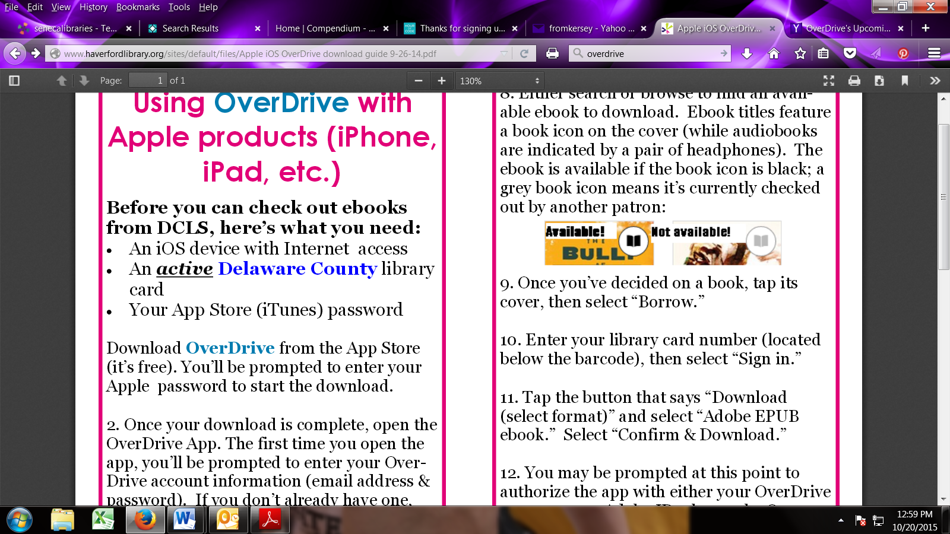

9. Once you’ve decided on a book, tap its

cover, then select “Borrow.”

10. Enter your library card number (located

below the barcode), then select “Sign in.”

*[If your number is less than 5 digits, you will need to add a 0 before your number.]*

11. Tap the button that says “Download (select one format)” and select “Kindle Book.” Select “Confirm & Download.” This should open Amazon.com.

12. Click “Get library book.”

13. If you are not logged into your Amazon account, you will be prompted to do so now.

If you already are, skip to step 15.

14. Select the device you wish to read your

eBook on and click “Continue.”

15. That’s it! You can now read your book on your Kindle Fire! It will be available on your bookshelf or in “Books” on your device.

Still have questions?

Check out OverDrive’s how-to videos and

other support materials:

<http://help.overdrive.com/>

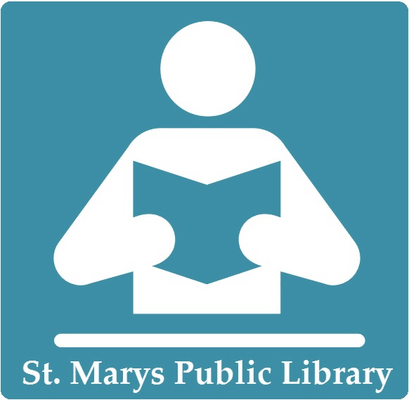

8. Either search or browse to find an available ebook to download.

Ebook titles feature a book icon on the cover (while audiobooks are indicated by a pair of headphones).

The ebook is available if the book icon is black; a grey book icon means it’s currently checked out by another patron:



9. Once you’ve decided on a book, tap its

cover, then select “Borrow.”

10. Enter your library card number (located

below the barcode), then select “Sign in.”

*[If your number is less than 5 digits, you will need to add a 0 before your number.]*

11. Tap the button that says “Download (select one format)” and select “Kindle Book.” Select “Confirm & Download.” This should open Amazon.com.

12. Click “Get library book.”

13. If you are not logged into your Amazon account, you will be prompted to do so now.

If you already are, skip to step 15.

14. Select the device you wish to read your

eBook on and click “Continue.”

15. That’s it! You can now read your book on your Kindle Fire! It will be available on your bookshelf or in “Books” on your device.

Still have questions?

Check out OverDrive’s how-to videos and

other support materials:

<http://help.overdrive.com/>

