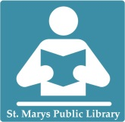

How to Download

Library ebooks

Kindle E-Reader

**Before you can check out ebooks from SMPL, here’s what you need:**

* An computer with Internet access
* An ***active*** **St. Marys Library** card
* Your Kindle / Amazon ID & Password
* Wi-Fi connection for Kindle

1. Go to: <http://b2gsdl.lib.overdrive.com/>

2. Use the search bar or browse to find an

available book that you wish to download.

Ebook titles feature a book icon on the cover (audiobooks are a pair of headphones).

The ebook is available if the book icon is black; a grey book icon means it’s currently checked out by another patron:

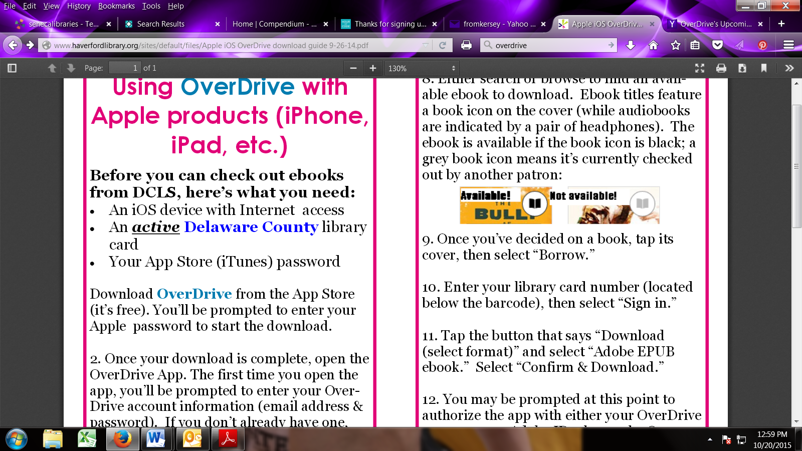

3. When you see a book you’d like to check

out, click on its title, then click “Borrow.”

4. Enter your library card number (located

under the barcode) and click “sign in.”

*[If your number is less than 5 digits, you will need to add a 0 before your number.]*

5. In your Bookshelf, click the button that

says “Download (Select one format)”

6. Select “Kindle ebook” then, click “Confirm

& Download” (this should open Amazon.com

in a separate tab or browser window).

7. Click “Get Library Book.”

8. If you are not logged into your Amazon

account, you will be prompted to do so now.

If you already are, skip to step 10.

9. Select the device you wish to read your

ebook on and click “Continue.”

10. That’s it! When you connect

your Kindle to wifi, your book will automatically deliver.

How to Download

Library ebooks

Kindle E-Reader

**Before you can check out ebooks from SMPL, here’s what you need:**

* An computer with Internet access
* An ***active*** **St. Marys Library** card
* Your Kindle / Amazon ID & Password
* Wi-Fi connection for Kindle

1. Go to: <http://b2gsdl.lib.overdrive.com/>

2. Use the search bar or browse to find an

available book that you wish to download.

Ebook titles feature a book icon on the cover (audiobooks are a pair of headphones).

The ebook is available if the book icon is black; a grey book icon means it’s currently checked out by another patron:



3. When you see a book you’d like to check

out, click on its title, then click “Borrow.”

4. Enter your library card number (located

under the barcode) and click “sign in.”

*[If your number is less than 5 digits, you will need to add a 0 before your number.]*

5. In your Bookshelf, click the button that

says “Download (Select one format)”

6. Select “Kindle ebook” then, click “Confirm

& Download” (this should open Amazon.com

in a separate tab or browser window).

7. Click “Get Library Book.”

8. If you are not logged into your Amazon

account, you will be prompted to do so now.

If you already are, skip to step 10.

9. Select the device you wish to read your

ebook on and click “Continue.”

10. That’s it! When you connect

your Kindle to wifi, your book will automatically deliver.