How to Download

Library ebooks

Nook & Sony Reader

**Before you can check out ebooks from SMPL, here’s what you need:**

* An ***active*** **St. Marys Library** library card
* A computer with an Internet connection

1. Start by downloading Adobe Digital Editions from [www.adobe.com/products/digitaleditions](http://www.adobe.com/products/digitaleditions). (It’s free!)

1a. During the installation of Adobe Digital Editions (ADE), you’ll be prompted to enter your Adobe ID and password. If you do not already have one, you can create one then by clicking “get an Adobe ID online.”

2. After downloading ADE, proceed to <http://b2gsdl.lib.overdrive.com/>

3. Use either the search bar or browse to find an available book that you wish to download.

4. When you see a book you’d like to check out, click on the cover.

5. Click “Borrow.”

6. Enter your library card number (located

below the barcode), then select “Sign in.”

*[If your number is less than 5 digits, you will need to add a 0 before your number.]*

7. Click “sing in.”

8. Click the button that says “Download (select format). ” Select “EPUB ebook.”

9. Click “Confirm & Download.” Your book will now automatically download to your computer.

10. Once the ebook has downloaded, it should appear on your computer’s desktop.

How to Download

Library ebooks

Nook & Sony Reader

**Before you can check out ebooks from SMPL, here’s what you need:**

* An ***active*** **St. Marys Library** library card
* A computer with an Internet connection

1. Start by downloading Adobe Digital Editions from [www.adobe.com/products/digitaleditions](http://www.adobe.com/products/digitaleditions). (It’s free!)

1a. During the installation of Adobe Digital Editions (ADE), you’ll be prompted to enter your Adobe ID and password. If you do not already have one, you can create one then by clicking “get an Adobe ID online.”

2. After downloading ADE, proceed to <http://b2gsdl.lib.overdrive.com/>

3. Use either the search bar or browse to find an available book that you wish to download.

4. When you see a book you’d like to check out, click on the cover.

5. Click “Borrow.”

6. Enter your library card number (located

below the barcode), then select “Sign in.”

*[If your number is less than 5 digits, you will need to add a 0 before your number.]*

7. Click “sing in.”

8. Click the button that says “Download (select format). ” Select “EPUB ebook.”

9. Click “Confirm & Download.” Your book will now automatically download to your computer.

10. Once the ebook has downloaded, it should appear on your computer’s desktop.

11. Double click the ebook icon to open the file in ADE. When the file opens, it should open the book.

12. If you want, you can read your ebook like this, on your computer. You can also transfer your ebook to your device.

13. Click the “Library” button in the upper left hand corner.

14. Connect your ereader (Nook, Sony Reader) with its USB cable.

15. Your ereader should appear under your “bookshelves.”

16. Click and drag your book (you’ll see it in the right hand pane of ADE) onto your device.

17. Eject your ereader from your computer.

You’re now ready to start reading!

Still have questions?

Check out OverDrive’s how-to videos and

other support materials:

<http://help.overdrive.com/>

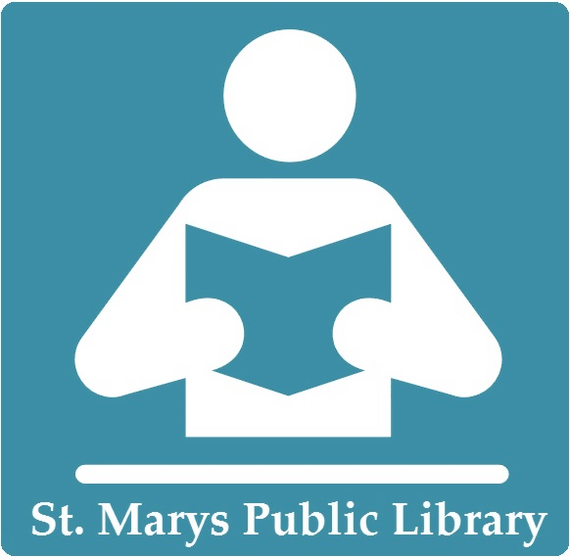

11. Double click the ebook icon to open the file in ADE. When the file opens, it should open the book.

12. If you want, you can read your ebook like this, on your computer. You can also transfer your ebook to your device.

13. Click the “Library” button in the upper left hand corner.

14. Connect your ereader (Nook, Sony Reader) with its USB cable.

15. Your ereader should appear under your “bookshelves.”

16. Click and drag your book (you’ll see it in the right hand pane of ADE) onto your device.

17. Eject your ereader from your computer.

You’re now ready to start reading!

Still have questions?

Check out OverDrive’s how-to videos and

other support materials:

<http://help.overdrive.com/>

